**COSC 4P02 Sprint 1 Design Diagrams - Minimalistic Accounting Web App (Accutrack - tentative)**

[***Use Case***](https://drive.google.com/file/d/1eZ-6vVZilf1VFEdoli_6-rK_m0-dDp5T/view?usp=sharing) ***and*** [***Abstract Process Models***](https://drive.google.com/file/d/13e72CDqWbVt6VNUhdP_L1pgd4dyG5Z5y/view?usp=sharing) ***located in the linked location.***

**Process Models (Sprint-1 Exclusive):**

Adding, Editing Deleting Income:

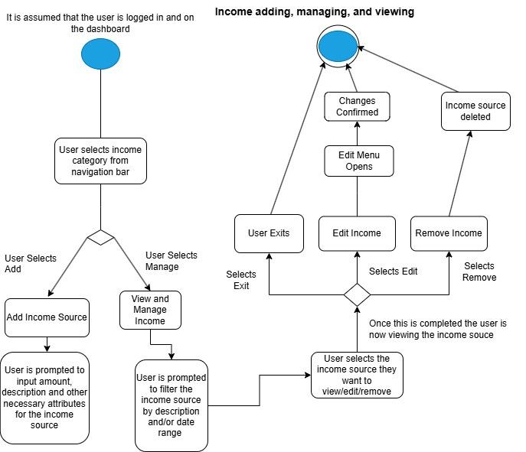

Adding Editing, Deleting Expenses:

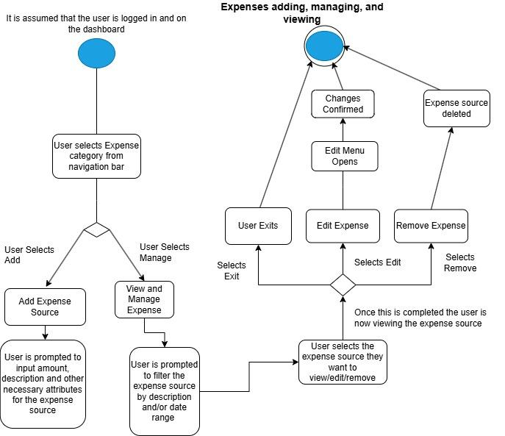

User Authentication:

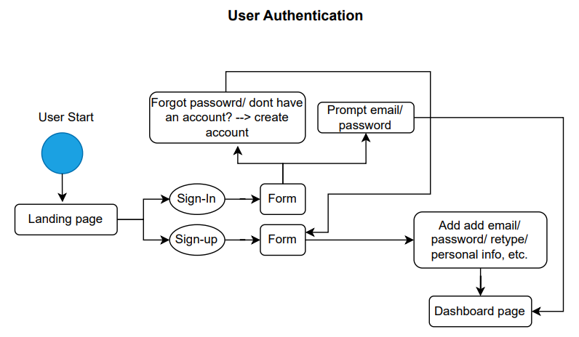

**Figma Design Diagrams (Front-End Markups):**

Landing Page:

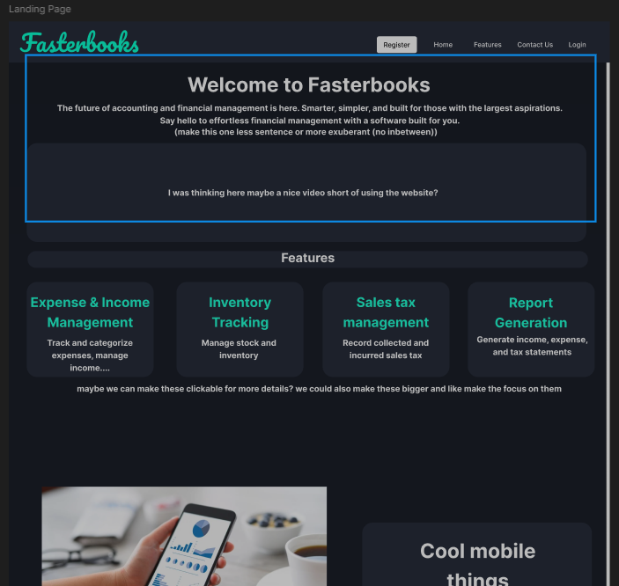

Login:

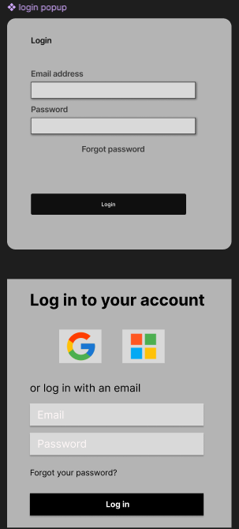

Dashboard:

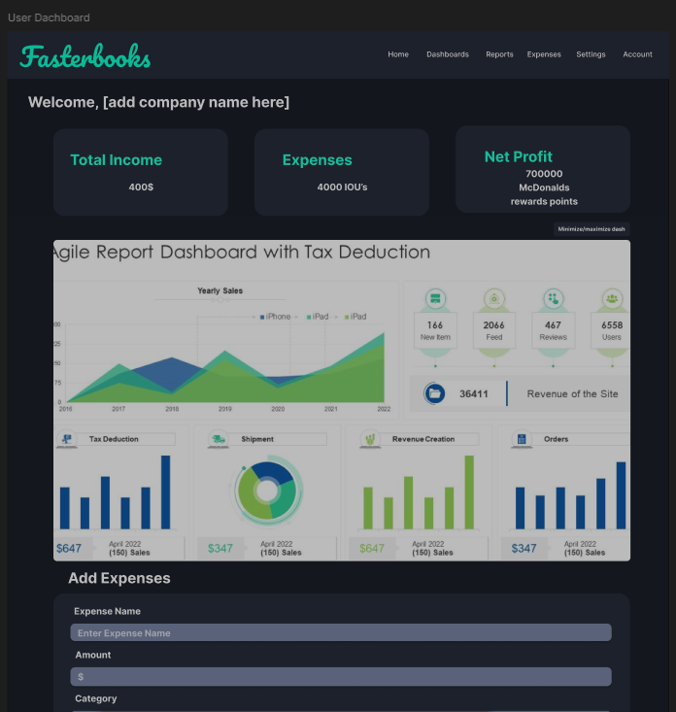

Sample Income/Expense Page:



**Database Schema (Sprint 1):**